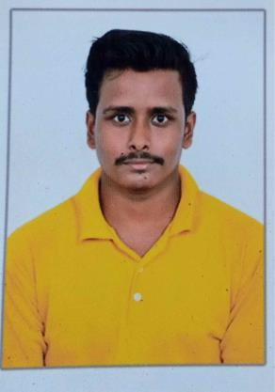**RESUME**

* Name – SUKUMAR SAU
* Vill - Kamarda, PO- Kamarda Bazar
* P.S – Khejuri
* Dist- Purba Medinipur
* Pin –721432
* Contact No :8343977640
* Email: [sausukumar727@gmail.com](mailto:sausukumar727@gmail.com)

**OBJECTIVE:** Put my best efforts for the overall betterment of the organization. Show and enhance my skills. Always attend to guest’s satisfaction.

# ACADEMIC QUALIFICATIONS :

|  |  |  |  |
| --- | --- | --- | --- |
| EXAMINATION | Board/Council/University | Year of passing | Marks obtained |
| 10 | W.B.B.S.E | 2014 | 51.8 |
| 12 | W.B.B.H.S.E | 2016 | 58.4 |

**WORK EXPERIENCE**:

* 1 years exp. Cook for Making south Indian food at Green park Resturant, Chennai. As a Commi 3 .
* 2 years exp . Cook for making South Indian food at Design Hotel, Chennai . As a Commi 2 .
* 6 Months exp. Cook fo making south Indian Food at Aamaze Hotel , Kolkata . As a Commi 2

# PERSONAL INFORMATION:

* **Date of Birth:**07 – 04- 1998
* **Marital Status:** Unmarried
* **Sex:** Male
* **Language Known:** Bengali & Hindi & Tamil
* **Nationality:** Indian
* **Strength:** Confident, attitude, Hardworking, Punctuality, Good listener and Quick learner

# DECLARATION:

I Here by inform you that all the statement made above are true the best of my knowledge and belief.

(Signature)